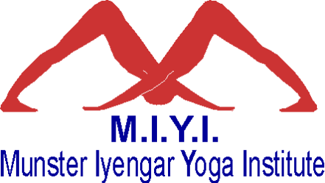
C/o Boru Oak Lodge
Raheen Road
Tuamgraney
Co. Clare
Ireland

27th February 2014

Yogacharya Sri BKS Iyengar
Ramamani Iyengar Memorial Yoga Institute
1107 B/1 Hare Krishna Mandir Road
Model Colony
Shivaji Nagar
Pune – 411 015
INDIA

Dearest beloved Guruji,

I am writing to let you know about National Iyengar Yoga Day, an event which took place all over Ireland on Saturday 18th January. This event was designed to help raise awareness of Iyengar Yoga across the country. 90% (64) of all certified Iyengar Yoga teachers in Ireland participated by teaching a one hour class in their locality free of charge. These classes were attended by over 700 students new to Iyengar Yoga and the profile of Iyengar Yoga was greatly raised by the publicity generated nationwide.

I enclose some further details regarding the event for your information.

With much love,

Susanne Sturton
Chair
Munster Iyengar Yoga Institute
www.miyoga.org

